Asia-China-Coin-Flat Handled Spade Money-Type 5, Three Hole Spades三孔布Sān kǒng bù

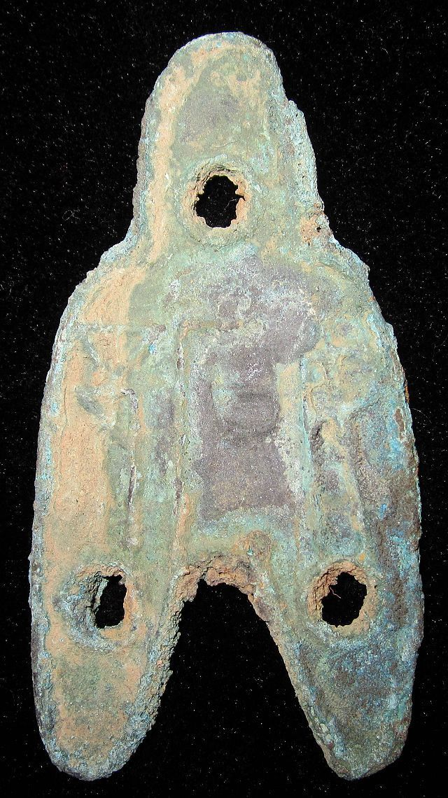 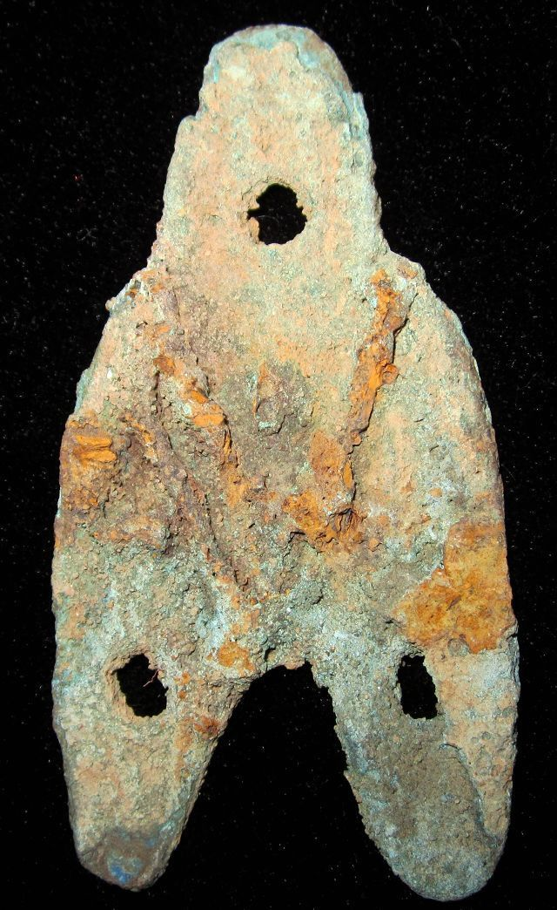

length 6.6CM/2.60Inches, width 3.4CM/1.34Inches

妬邑一两 三孔布."妬邑" Dù yì yī liǎng sān kǒng bù."Dù yì .The town Dù where the coin was minted is named on the obverse,"一两"on the back. It was used in the Zhao Nation, late warring sates period.

